1.3 Create Class Account with data member as Balance. Create two constructors (no argument, and with argument0 and perform following task.

* Method to deposit the amount to the account
* Method to withdraw the amount from the account
* Method to display the Balance

Input;

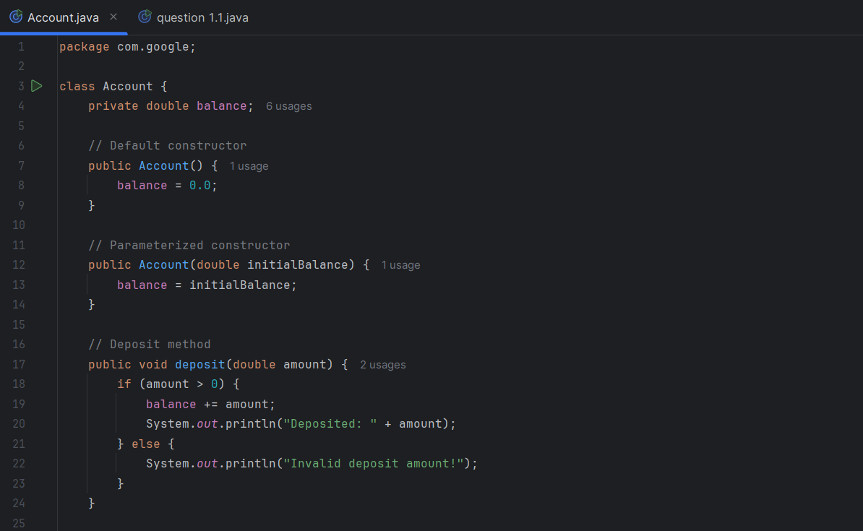

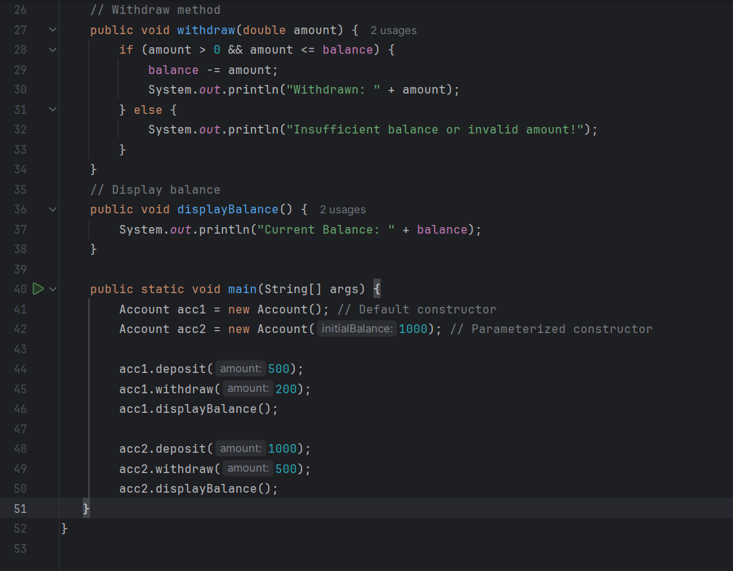

Output;

